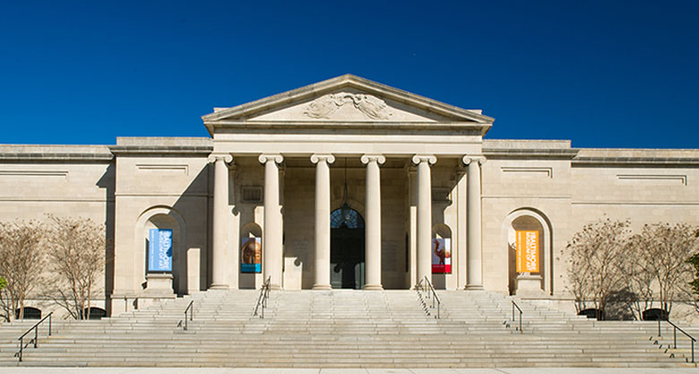HOUSEUM ART OF CHICAGO

Bus-Z 445 Phase One

HOUSEUM ART OF CHICAGO

Houseum Art (HAC) is one of the oldest and largest art museums located near Water Tower Place in downtown Chicago, Illinois. The museum was founded in 1973 by a group of 10 artists who love acquiring a collection of art and found it appropriate to open HAC in Chicago as a way of preserving and showcasing the works of art. The museum is devoted to modern art and has held most of the works of art from all over the world since its founding. HAC has been in the industry for 47 years and employed over 56 employees to keep on staff at any given time. The museum boasts a gift shop, bookstore, food court, and theater as for the visitor’s enjoyment during their visit.

The museum builds, preserves, studies, and shares its outstanding collections of art from all over the world while creating a sense of community with the audiences. The museum plans to continue to foster and build the community of artists as well as supporters of the arts. The museum is one of the public favorite destinations in downtown Chicago due to the museum’s continued commitment to remaining easily accessible and available to the public. The museum has boosted attendance to an average of 60,000 to 75,000 visitors a year.

The mission of the HAC is to be an innovative center of art where people can experience the work and ideas of artists and understand the historical, cultural, economic, and social context of the art at its time. The museum links exhibitions, collections, events, educational programs, and performances to create an exciting atmosphere for the visitors. Below is the Houseum of Art’s strategic goals to enhance museum ability.

The Museum’s Strategic Goals:

- Increase the public awareness of the museum through exhibitions and events
- Expand public access to the museum, making it fully accessible to the audiences
- Act as a place for discussion about art and culture
- Addressed any relevant issues within the museum for the audiences
- Increase opportunities and support for public art and individual artists.
- Develop a culture educational opportunities at the local and regional level.
- Strengthen relationships between Houseum Art of Chicago, regional arts, and other cultural organizations.

Job Description

Location: Chicago, Illinois Job Type: Full Time

Position Title: Special Events Coordinator Salary: $35,000-$42,000

Reports to: Senior Manager FLSA: Exempt

Job Specification
As an event coordinator, you will be specifically required to sell and collect fees from company clients, contacting and planning events with organizations, record all the details of the attendees and the event’s sales, prepare receipts and place reservations accordingly. You will also be required to provide clients with information about the facilities, including orienting the clients with the specific rules and regulations they should adhere to while within the facility. You shall also be required to direct guests to their seats or exhibits as needed.
Job Purpose:
To support the department with planning and execution of internal museum events.
General Position Summary:
The Events Coordinator will manage, plan, and coordinate all of the Museum’s events and perform other general department administrative duties as directed. This individual will work with the team to plan and execute events as needed. The coordinator should exhibit professionalism and have a passion for providing extraordinary hospitality to the visitors.
Essential Duties And Responsibilities:
- Greet, anticipate, and fulfill guests need to exceed the expectations
- Understand, confirm, plan, and execute all elements of event orders
- Support planning and execution of special events including paid events, fundraising events, and membership events
- Record all the details of the attendees and the event’s sales, prepare receipts, and placing reservations accordingly
- Generate repeat bookings by maintaining existing client relationships
- Oversee the events from the start through post-event
- Conduct inspection at the end of each event
- Orienting the clients with the specific rules and regulations of the Museum
- Participate in the meetings with the internal event support team
- Perform other duties as assigned

Qualifications:

- Education- Bachelor’s degree in public relations, event management or related field.
- Skills:
  - Must possess excellent communication skills
  - Demonstrated excellence in customer service
  - Proficiency with Excel and database management tools
  - Strong work ethic, reliable, and dependable
  - Ability to work as a team as well as independently
  - Strong interpersonal skills to maintain positive working relationships with others
  - Must be able to successfully plan and flawlessly execute the events
  - Strong project management, time management, and organizational skills
  - Must be able to make the best possible decision in any circumstances
  - Must be able to multitask effectively in a fast-paced environment
  - Must be able to stand on feet for extended periods of time

- Experience- At least one year of management related experience preferred
- Schedule- Must be able to work days, evenings, and weekends
- Benefits:
  - Health Insurance
  - Dental Insurance
  - Vision Insurance
  - Paid Time Off
- Work Environment:
  - The coordinator will work year-round both in the office and indoors or outdoors as needed. Typically, this job requires the coordinator to stand, sit or walk for extended periods of time and to lift up to 30 pounds.

TO APPLY FOR THIS POSITION:
- Complete the online application at HouseumArtofChicago.com
- Attach current resume and cover letter detailing your experience
- Contact the Hiring Department for any questions

Subject Matter Expert Interview:
Ramiro Rincones
Sales and Planning Manager Department: Event and Conference Services
Phone: 317-274-0364 Address: Hine Hall 875 W. North Street, Suite 224
Email: ramrinco@iu.edu Indianapolis, IN 46202

Ramiro Rincones is a Sales and Planning Manager in the department of Event and Conference services in IUPUI. He has been planning and coordinating events for 9 years. He brings a lot of external organizations to the IUPUI campus, anyone outside of the IU field that would like to do an event at IU will contact him and he will be the person handling all the sales for selling spaces and working on the budget for them to meet their requirements. In addition, he does a marketing job by reaching out to external groups and asking them for their needs and requirements for hosting an event and trying to make them contract with IUPUI, so basically bringing in business to the University is one of his responsibilities.
He does everything from the logistical aspect of the planning event, working with a client to make sure everything they need logistics and space is reserved and ready for them at the wanted time. He has the power when it comes to decision making which he uses when there are small issues, but when it is a major one he prefers consulting with his team. For space prices, they already have set prices, there are three categories rates which are internal rate, nonprofit rate, and external rate. For any additional cost like planning, vendor tables, or exhibit stands his team will determine the cost as a team.
As an event coordinator, every day is not the same, planning and coordinating events are pretty much what takes his workday. How much work he does every day varies from time to time, it depends on how many events and conferences he is coordinating in a week. Meeting with clients face to face or via phone to get information about what they need for an event or a conference, working on their budget limit, provide them with what they want, and making sure everything is in order at the time requested are ones of his basic daily duties.
One of the biggest challenges he faces as an event coordinator is weak communication with clients, he needs to gather as much information as he can to share with his team to operate and coordinate the event and some of the clients do not share enough information or forget to update or change their requests. For a successful event organizing, both the event coordinator and the client should clearly communicate with each other and address everything they need for the event and keep the coordinator updated if there is any change in the plan.

Event coordinating is one of the top 5 most stressful jobs in the US, so to be successful at this job you must have certain characteristics that you should have like passion, time management, and flexibility. Ramiro thinks passion is number one because planning an event could get overwhelming, so you have to enjoy and love what you do to be successful at it. Time management and balance are important because this job is time-consuming and you have to find a balance between work and life to not get yourself stressed out and fail at this job.
Recruiter Interview:
Mary Vain Phone: 317-334-3253
Talent Acquisition Manager Email: MVail@childrensmuseum.org
The Children’s Museum of Indianapolis
Mary Vain is a talent acquisition manager from the Children’s Museum of Indianapolis, Indiana. My first impression of Mary is that she is very busy when it comes to her daily tasks in this position. I base this off the fact that she had to place me on hold a couple of times to take care of urgent matters that were presented to her. After her business was attended to, I proceeded with the interview by going more in-depth with various ways that people first go about applying for a position at the Children’s Museum, even though it is a well-known place in downtown Indianapolis.
Her reply was that it is much more streamlined, these days, to apply to their specific location because they primarily focus on online avenues for possible applicants to quickly and efficiently submit a form for the position, rather than using paper. A part of that application includes a questionnaire that would be found on most applications for a job. Questions that can be found in this questionnaire include “Are you 18 and older?”, Are you legal to work in the United States?”, and more detailed questions listed within the application. Along with that, she referred to the system that they use for applications is the APO system. Mary continued by explaining that once an application goes through on their system, she then reviews the applicant’s credentials to see if they positively match up to the standards that the company has in place for what they are looking for in an employee. If the credentials of the applicant are comparable with the standards they are looking for, there will be a follow-up interview, by phone, that will ask the opinion of the applicant about what they’re looking for in the job, more information about what they’re like personality-wise, and things of that nature. This is also a chance to clear up any confusion, whether it be on the applicant’s side or on the side of Mary’s end.
The next thing we touched base on was the different sources of recruiting they have used in the past to draw more attention to their company and the great work environment that they have at the Children’s Museum. Mary insisted that the best source, as of late, has been their use of job fairs at several locations to bring the first steps of employment to the feet of the possible employees. She also brought up the fact that most companies don’t turn to job fairs because they are seen as a waste of time, resources, and effort. With that being said, she went on to say that its actually been the contrary as she has acquired over 6% of her new incumbents through the usage of job fairs, specifically part-time roles. Another source for her recruiting is described as work-of-mouth and using the diverse culture that they have to bring about awareness for an amazing opportunity for someone looking for a career in a museum. A few online sources are mentioned such as Indeed.com and Facebook. They use these methods to span across multiple channels to allow for maximum effect in seeking new employees.
The last thing that I talked about with Mary was the different questions that she might ask during an interview. Whether they be broad or specific or any other details such as that. Her answer seemed to point to more broad-based questions like why is it that you’re looking at this company and why you might be interested in a role with us. Another important question to her was asking about the specific strengths and weaknesses that the interviewee has. This gives her great insight into seeing how the person describes themselves and Mary believes that this question is very useful when trying to find out who has what kind of personality. After these questions have been asked, she then switches to more behavioral-based questions to get a sense of how that person reacts in certain scenarios. Examples of this would be how someone fares under an intense emergency situation or how the candidate might respond to critical feedback given to them by another.
Overall, my phone interview went very well with Mary and I’m glad she took the time out of her busy schedule to speak with me and provide me and my partners a better perspective on the inner workings of the hiring process that is needed for a company like the Children’s Museum of Indianapolis.


About Chicago, IL

Chicago is a great place to live for those who want a busy urban hub and less cost of living than New York and Los Angeles. There is extensive public transportation, great jobs, and plenty of diversity. Chicago, Il had a population of 2.71M people, 33.3% White alone, 29% Black or African American alone, and 28% Hispanic or Latino. It is a multicultural city with many business opportunities and it is also one of the most visited cities by tourists in the US with 58 million visitors in 2018. Chicago is also known as a very passionate sports town with 8 major league sports teams and more than 300 fields of soccer and American football. Below are the details of some of the positives and negatives of Chicago.

Diversity:

Chicago is home to a population of 2.71M people from which 89.7% are citizens and the rest of the residents were born outside of the country. The most common foreign languages spoken in Chicago are Spanish, Chinese, and Polish. We believe that this large amount of diversity will impact our recruitment services to attract individuals from different ethnicities. Diversity information can be found below.

Race | Ethnic Composition of the population
White | 33.3%
African American | 29%
Hispanic | 28.7%
Asian | 6.65%
Two or more races | 2%
American Indian & Alaska Native | .9%

Economy:
The median household income grew from $55,295 to $57,238, a 3.51% increase between 2017 and 2018. The median property value in Chicago, IL is $271, 600 and the homeownership rate is 45.7%. The economy of Chicago is huge and has employed 1.37 Million people. The largest industries are Healthcare and social assistance with 183,553 employees, second is professional scientific and technical services with 158,206, and third is educational service with 135,976 employees. The highest-paying industries are oil and gas extraction with $100,794, second is Finance and insurance with $78,177, and third public administration with $75,300. Below is the comparison chart of household income in Chicago, IL to its neighboring and different geographics.
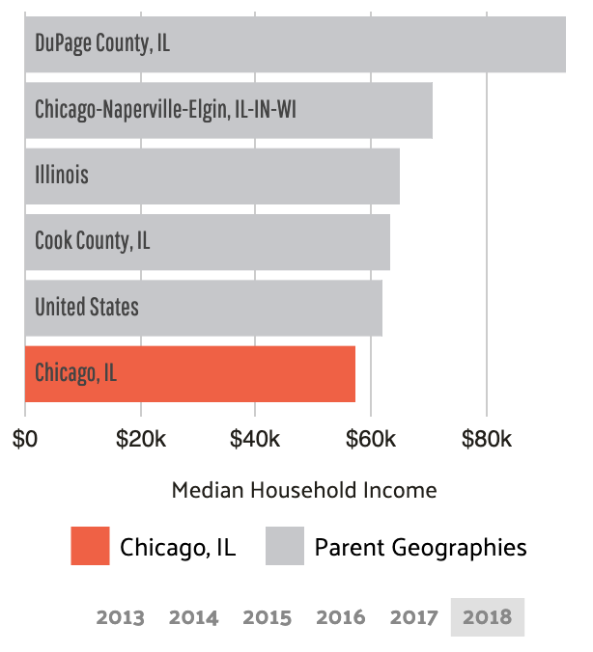
*The below chart illustrates the primary industries for residents in Chicago, IL.
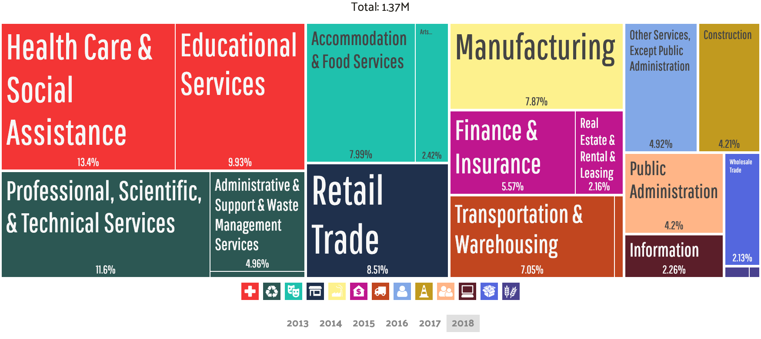

Commuter Transportation:

The most common method of travel for workers in Chicago was Drove Alone at 48.9%, t public transit at 28.3% and carpooled at 8.33%. Those who don’t have cars most rely on a combination of bus and subway services. An unlimited monthly pass from the Chicago Transit Authority costs $105, which is more than in Los Angeles but much less than in New York. The following chart shows the number of workers using different transportation over time.

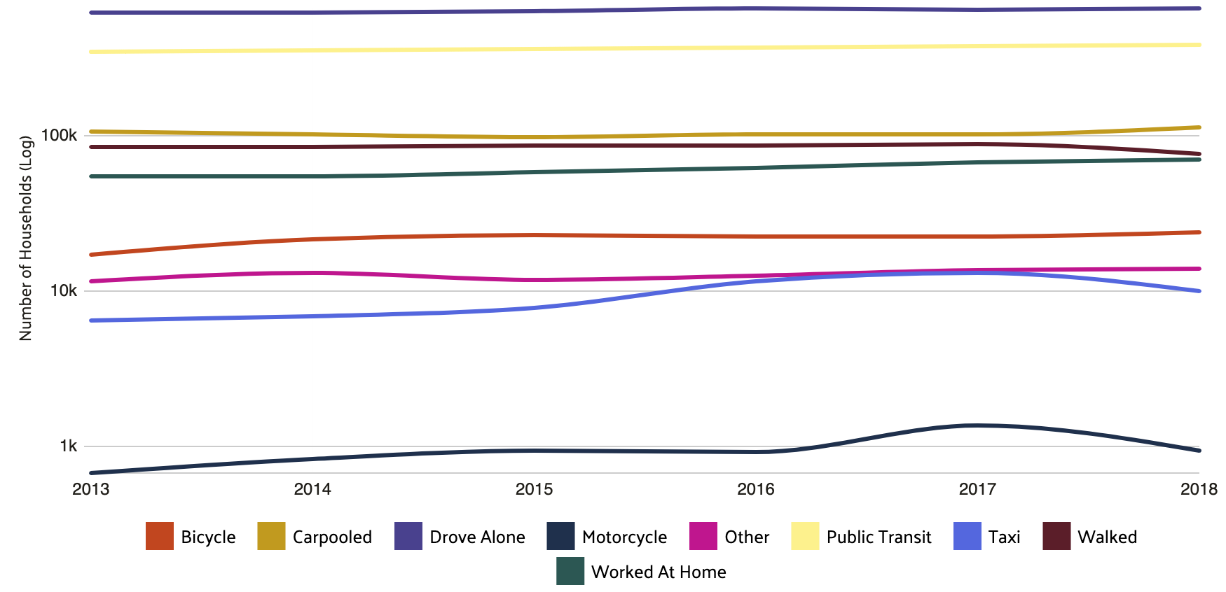

Activities:
Things to do in Chicago are not hard to come by. Whether it be attractions, special events, outings, or something to do during your downtime, Chicago is filled with many different forms of fun nights out on the town. Some activities to consider when in Chicago would be the 360 Observation Deck that sits on top of the Hancock Center in the heart of downtown. This gives a person a stunning view of the surrounding city that leaves a person speechless. Along with the Observation Deck, you can also schedule a helicopter ride to get an even better view of the city and embrace the rich culture of the city limits.

The Food:

One of the best things to think about when thrown into the middle of Chicago is the wondrous food that inhabits the city. Of course, on top of the list, is the Chicago style pizza that you can find in most pizzerias throughout the city. Another little known delicacy found in this city are the donuts. Lastly, there is the classic food from Portillo’s. Known for the signature hotdogs, they go the extra mile to make sure that Chicago is your favorite place for a hot dog.
Chicago Cost of Living Index:

From the list, it is clear that the overall cost of living index in Chicago is 110, which is 12% higher than the Illinois average and 10% higher than the U.S. average. Chicago has an extremely higher cost of living than most of every other city in the United States. However, everyday goods and services provide an accurate measure of the general cost of goods in any given city. Therefore, Chicago's goods and services are higher than the Illinois average and U.S. Average.

Index | Chicago | Illinois | National
Cost of living index | 110 | 98 | 100
Index | Chicago | Illinois | National
Goods & Services index | 109 | 98 | 100
Groceries index | 104 | 97 | 100
Health care index | 100 | 100 | 100
Housing index | 117 | 95 | 100
Transportation index | 125 | 112 | 100
Utility index | 93 | 97 | 100

Works Cited

Areavibes. “Chicago, IL Cost of Living.” Chicago, IL Cost Of Living. N.P.
<https://www.areavibes.com/chicago-il/cost-of-living/#goods-services>

“Chicago, IL.” Data USA, datausa.io/profile/geo/chicago-il#demographics. N.P.
<https://datausa.io/profile/geo/chicago-il#demographics>

“Business Name Generator - Powered by AI.” Namelix <namelix.com/app/?keywords=Chicago+art+museum.>

“Facts & Statistics.” City of Chicago, www.chicago.gov/city/en/about/facts.html.
<https://www.chicago.gov/city/en/about/facts.html>

Rackl, Lori. “Chicago Sets New Tourism Record with Nearly 58 Million Visitors in 2018 - and the Mayor Is Thrilled.” Chicagotribune.com, Chicago Tribune, 23 Aug. 2019,
<https://www.chicagotribune.com/travel/ct-trav-chicago-tourism-record-numbers-2018-0111-story.html>

